Control part:

In the real world, the operation of DC motor is the transfer from electrical energy to the mechanical rotation of motor. Therefore, the electric circuit of motor operation is composed by the input power (V (v)), terminal resistance (R ($Ω$)), Inductance (L (wb)), and the electromotive force (em (w)). In this case the formulas for the time domain and frequency domain are (i is the current of the circuit):

$V=Ri+L\frac{di}{ⅆt}+ⅇm, V\left(s\right)=RI\left(s\right)+LsI\left(s\right)+Em\left(s\right)$ [Eq.1,2]

For the mechanical rotation, the relationship among torque (T (Nm)), moment of inertia (Im ($k{gm}^{2}$)), angular displacement ($θ$) and the friction coefficient (b) in time domain and frequency domain are given:

$T=\operatorname{Im}{\frac{ⅆ^{2}θ}{ⅆt^{2}}}+b\frac{ⅆθ}{ⅆt}, T\left(s\right)=Ims^{2}θ\left(s\right)+bsθ(s)$ [Eq.2, 3]

In this case, angular velocity is proportional to the electromotive force and current is proportional to the torque of the motor. ($K_{e}$ is the electrical motor constant, $K_{t}$ is the mechanical motor constant):

$ⅇm=K_{e}\frac{ⅆθ}{ⅆt} Em\left(s\right)=K_{e}sθ\left(s\right), T=K_{t}i T\left(s\right)=K_{t}I(s)$ [Eq.3,4,5,6]

In order to find the response between angular position ($θ$) and input voltage (v) in time domain, the Laplace transfer function by combination of Eq.2, Eq.3, Eq4 and Eq.6 is shown below:

$\frac{θ\left(s\right)}{v_{\left(s\right)}}=\frac{K_{t}}{bR_{s}(\frac{K_{e}K_{t}}{bR}+τ_{e}τ_{m}s^{2}+τ_{m}s+τ_{e}s+1)}$ [Eq.7]

Note: $τ_{m}$ is the mechanical time constant of motor ($τ_{m}=Im/b$), $τ_{e}$ is the electrical time constant ($τ_{e}=L/R$)

Assumption: Because the electrical time constant ($τ_{e}$) is much smaller compared to the mechanical time constant of the motor ($τ_{m}$), term $τ_{e}τ_{m}s^{2}$ and $τ_{e}s$ are approximately equal to zero compared with other terms. Therefore, the equation will become: (Answer for Q1.1, 1.2)

$\frac{θ\left(s\right)}{v_{\left(s\right)}}=\frac{K}{s(τs+1)}$ ($K=\frac{k_{t}}{bR+K_{t}K_{e}},τ=\frac{τ_{m}Rb}{KKt+Rb}$) [Eq.8]

Due to the angular velocity ($w$) is the first derivative of angular position related to time ($w\left(s\right)=s∙θ\left(s\right)$). In this case, the transfer function of angular velocity and input voltage is (Answer for Q1.1):

$\frac{w\left(s\right)}{v_{\left(s\right)}}=\frac{K}{(τs+1)}$ [Eq.9]

According to the specification data of Motor C42-L50 winding code 10 [1]:

|  |  |
| --- | --- |
| Torque sensitivity (Kt) | 0.1412 Nm/amp |
| Back EMF (Ke) | 0.1413 volts/rad/sec |
| Rotor inertia (Im) | 6335.4 $×{10}^{-7}$ kg/m^2 |
| Mec. Time constant ($τ_{m}$) | 0.0223s |
| Terminal resistance (R) | 0.7 $Ω$ |
| Friction Coefficient ($I_{m}$/ $τ_{m}$) | 0.0285 |

Table 1: Data of motor C42-L50 adapted from the C42 series specification [1]

Therefore, constant K and overall time constant $τ$ can be calculated:

$K=\frac{k_{t}}{bR+K_{t}K_{e}}=3.54 , τ=\frac{τ_{m}Rb}{KKt+Rb}=0.0112$

In this case, the transfer function of angular velocity and angular displacement of motor with voltage input is:

$\frac{w\left(s\right)}{v_{\left(s\right)}}=\frac{K}{(τs+1)}=\frac{3.54}{0.0112s+1}$ (gain: 3.54), $\frac{θ\left(s\right)}{v_{\left(s\right)}}=\frac{K}{s(τs+1)}=\frac{3.54}{0.0112s^{2}+s}$

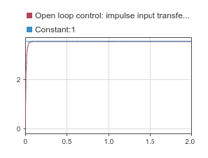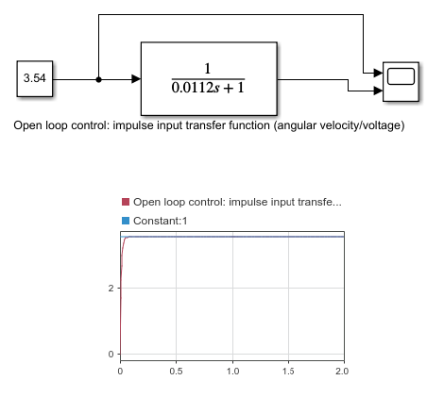Model of open loop transfer function of angular velocity in Simulink (Q1.1):

**Graph1:** Model of open loop transfer function of angular velocity with **impulse input.**

**Results analysis:** the response can reach desired target exponentially without oscillation.

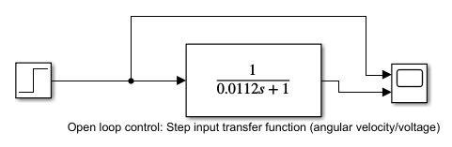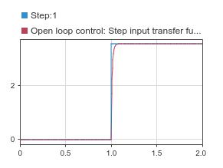

**Graph2:** Model of open loop transfer function of angular velocity with **step input.**

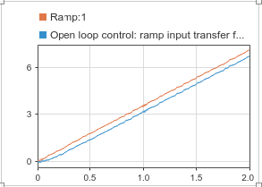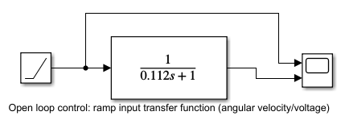**Results analysis:** the response can reach desired step input exponentially without oscillation.

**Graph3:** Model of open loop transfer function of angular velocity with **ramp input.**

**Results analysis:** the response cannot reach the desired input and has a steady state lag.

Model of open loop transfer function of angular displacement in Simulink (Q1.2):

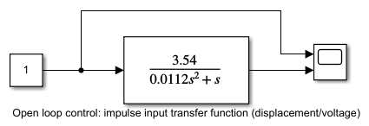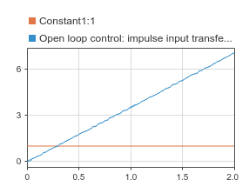

**Graph3:** Model of open loop transfer function of angular displacement with **impulse input.**

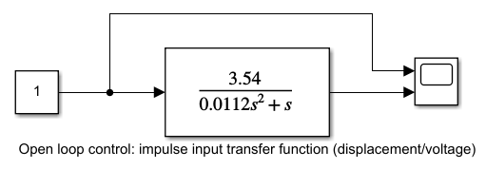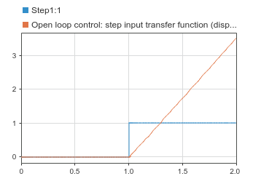**Graph4:** Model of open loop transfer function of angular displacement with **step input.**

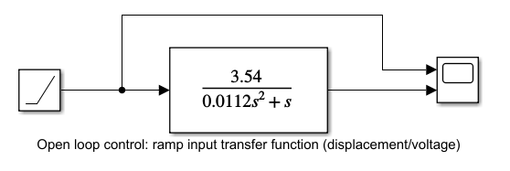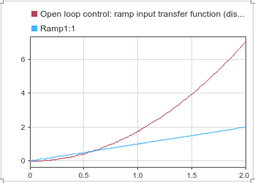

**Graph4:** Model of open loop transfer function of angular displacement with **ramp input.**

**Result analysis:** According to the results shown in Graph3,4,5, the response of output angular displacement will intersect with input and then overshot to infinity (undesirable behavior), which mean these open loop cannot meet the requirement to control the angular displacement of motor.

Under this circumstance, the unit feedback closed loop with a gain of H is required to overcome this undesirable behavior of open loop control system for angular velocity. The formular for the feedback loop is: ($G\left(s\right)=\frac{θ\left(s\right)}{v_{\left(s\right)}}=\frac{3.54}{0.0112s^{2}+s}, H\left(s\right)=H, H is a constant$)

$G^{'}\left(s\right)=\frac{G(s)}{1+G(s)∙H(s)}$ [Eq.10]

Therefore, the new transfer function is:

$$G^{'}\left(s\right)=γ\frac{w_{n}^{2}}{s^{2}+2{ζw}_{n}s{+w_{n}^{2}}}=\frac{316.07H}{H(s^{2}+2×44.64\sqrt{\frac{1}{316.07H}}∙\sqrt{316.07H}s+316.07H)}$$

Note: $γ=H$, $ζ=44.64\sqrt{\frac{1}{316.1H}}$, $w_{n}=\sqrt{316.07H}$

In this case, we can use $ζ$ to determine the response wanted as overdamped, critically damped. Underdamped or undamped to control the loop without undesired behavior and according to the results and analysis of transfer function of angular velocity, step input is suitable to make the response reach the desired input compared to ramp input and impulse input. Therefore, the step input is the input for the new transfer function to overcome the undesirable behavior.

The results of the simulation from Simulink are shown below:

|  |  |  |
| --- | --- | --- |
| Response | Value of $ζ$ | Model |
| Overdamped | $ζ>1$, $0<H<6.304$ ,  H=1 in this case |  |
| Critically damped | $ζ=1$, $H=6.304$ , |  |
| Underdamped | $0<ζ<1$, $H>6.304$,  H=30 in this case |  |
| Undamped | $ζ=0$, $H=∞$, | Because $w_{n}$ is also depends on H, so there is no Undamped condition in this case |